TITLE IN ALL CAPS
Authors

This is a Heading
This document can be used as a template to describe elements for submissions to the Huntsman School of Business Teaching Series (HSB Teaching Series). Our aim is to have standardized style for all documents that looks professional and is accessible to sighted, low vision, and blind readers. The style considerations are put in to ensure an accessible and inclusive experience for all students and instructors who may use your resource in the future.

Using Style Panes
Using Styles in Microsoft Word provides a consistent, professional look and makes it easier for readers with disabilities to access the content. The Style Panes in Microsoft Word makes it easy to style document elements appropriately. This document has the correct styles for specific elements of your document. For example, once you start a new section heading, highlight the words you want to become the heading and click on Heading 2 in the Style Panes – this will make sure the correct style is used and will also add the appropriate metadata to the document in order to allow better accessibility to low vision and blind readers. We will focus on the following styles:
- Heading 1 is reserved for Titles
- Heading 2 for all other headings
- Normal for regular text
- Authors for author’s names
- Footer and Header for text in the headers and footers
- Caption to use for captions of figures and tables

Fonts and Spacing
We recommend using this document as a template by copying and pasting your text into this document and utilizing the style guide. The following is built into the styles of this document:
- The preferred font for all text is Arial.
- Normal text uses font size 11, line spacing is set at 1.15.
- The Title uses size 14, bolded, all caps, use Heading 1 style.
- Headings of sections use size 12, bolded, use Heading 2 style.
- Captions for tables and figures use size 9, italicized, and centered; figures are labeled automatically by right clicking on the image and selecting “insert caption.”
- Footer and footnotes use size 7.5.
- Use bullet points when listing items.
- Use bold or italics for emphasis but do so sparingly.
Please avoid using any other fonts or size. Notice that paragraphs are not indented, but instead are separated by a space between paragraphs that are automatically inserted with the style. All styles have appropriate spacing before and after text so extra spaces should not be necessary.

Check Accessibility
Before you submit your document, take a brief moment to use the built-in Word Accessibility Checker to make sure there are no accessibility errors in your document. There is some support built-in to the checker to understand how to fix any errors.
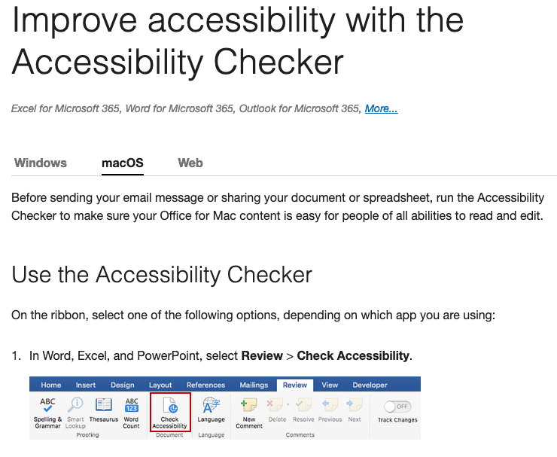
Figure 1: This is a Caption: Screen Shot of Accessibility Checker location on Microsoft Word
found at https://support.microsoft.com/en-us/office/improve-accessibility-with-the-accessibility-checker-a16f6de0-2f39-4a2b-8bd8-5ad801426c7f

Headers and Footers
Please update the header on the first page to include the month and year of publication. There is space in the header for subsequent pages to include the title – change the title on the headers of both page 2 (top right-hand side) and page 3 (top left-hand side) and all other pages should reflect your changes. Also, if a teaching note is available for the document please put your contact information (email) in the footer on the first page for instructors to be able to ask for your teaching notes. With exception of the first page, each page should include the page number centered on all footers.

Footnotes and Hyperlinks
Citations should be in Chicago format as footnotes. Footnotes are used for two reasons:
- To cite a source that is paraphrased or directly quoted.
- To provide additional material.
If you are including a hyperlink in the text, avoid statements such as “click here to learn about…” Instead, fully describe where the link will take you. For example, the following link to an article by the Regional Government Services describes more about accessible writing styles. Also, you can use the “Hyperlink” style to reapply to any hyperlink that may lose its blue underlining when using styles.

Creative Common Licensing
HSB Teaching Series submissions are hosted by the USU Open Education Resources (OER) collection which implies that they will be publicly available and will hold open-source licenses by Creative Commons Licensing. The default license for submissions will be Attribution-NonCommercial-ShareAlike meaning others are free to share and adapt the content as long as there is appropriate attribution, the material is not used for commercial purposes, and any contributions and adaptions are kept under the same license as the original. The license is displayed on the footer of every page.
In order to use this license, content needs to be free of copyright material including pictures, graphs, or other exhibits. Content should be either created or owned by the authors, or come from open-source image sources. Alternatively, authors can get permission to use and license content from original owners. If you have questions about copyright or need additional support please visit https://library.usu.edu/copyright/ or email copyright@usu.edu.

Types of Content
The HSB Teaching Series hosts teaching material that could be used in undergraduate and graduate business and economics higher education courses in any domain. Teaching material content in the HSB Teaching Series are intended as Open Educational Resources (OER). OER are openly licensed materials that allow users to freely retain, reuse, revise, remix, and redistribute the content. HSB Teaching Series content should facilitate teaching principles, theories, concepts, and methods in our learning environments in engaging, relevant ways that promote learners’ application of concepts and ability to think critically. Content is to be used as a part of classroom curriculum not just as a report or essay.
Content can be created with two intentions:
- To assign to learners to read and to use to facilitate learning; and,
- To describe context specific innovative teaching plans, learning techniques, and teaching material to be used by other instructors.
Content could include the following:
- Case Studies
- Learning exercises
- Teaching notes
- Classroom innovation briefs
- Simulations or learning games
Most content will be published as PDF documents unless there is some other format that better facilitates learning.

Teaching Notes
To further stress the importance of learning outcomes in the pedagogy, publications in the HSB Teaching series are limited to only those with an accompanying teaching note that details the principles, concepts, theories, or methods that the submission can be used to teach, and includes a teaching plan to facilitate an instructor’s use of the submission.

Submission and Review Process
- Editor review: Upon initial submission from the author on the submission website, the editor (or a review committee member who is more familiar with its domain) will read the submission to assess whether it aligns with the teaching series and the values and image of the HSB brand. They can reject the submission or provide guidance to the authors to achieve a more aligned submission.

- Solicit peer reviews and endorsements: The editor or committee members will solicit two peer reviews to review the submission for fit and quality. The review process is single blind – reviewers will know the names of submitting authors.

Reviewers are asked the following:

  - Will the content engage students? Will it lead to engaging classroom learning?
  - Will the content teach principles, concepts, theories, or methods that are important to the corresponding discipline ? Is it clear what students will learn from the content?
  - Does the teaching note adequately describe the principles, concepts, theories or methods? Does it provide adequate direction and context to fully leverage the submission for student learning?
  - Is the submission substantial enough to be considered a stand-alone publication? Does the length of the submission seem appropriate for the intended learning outcomes and audience?
These questions will be used to suggest revisions to improve the content.
Teaching series committee members can serve as reviewers. Reviewers may also be faculty at other accredited universities outside of USU. Since the review process is not blind, authors can show potential reviewers the content prior to submission in order to solicited feedback prior to the formal review process.
- Submission and Copy Editing: Once a submission is accepted for publication a copy editor will check that content is appropriately formatted and free of grammatical errors, and work with the author to improve readability if needed.

Permission process
- Copyright permissions: After being accepted, the submission is sent to the USU Library staff to ensure that there are no copyright issues. If permissions are needed, they will work with the author to get permissions or make changes accordingly. To publish with OER, there cannot be copyrighted material (pictures, visuals, etc.) without permission from the originator.

- Organization permission: If proprietary information was used for the case study, it is common courtesy to get permission from the organization. Cases are not intended to be fully factual or historical, so organizations and authors can choose to change data and facts so as not to divulge proprietary information. If the case was written using only public data and no personal contact was made with the organization, permission is not required. However, if there is a personal contact within the organization that assisted with the case, the authors are expected to get permission from the organization before publication.

- Plagiarism check: As a final check, the submissions will be run through Turn-It-In plagiarism check software.

Acceptance
Once everything is cleared, the content is published. The authors will be given a link as well as a citation reference with date and issue of the series. Teaching notes will have separate links that will not be searchable so that students cannot find them. Authors will be responsible for distributing teaching note links to interested faculty members. The number of downloads will be available on each webpage.

Outside of USU HSB
Use of content outside of USU will be encouraged through the use of Creative Commons licensing. Case and other content can be downloaded by faculty and students anywhere in the world for free.
Additionally, content authors from outside HSB and outside USU will also be considered with the adequate submission review and permission processes.

Gahan, Courtney. “How and When to Use Footnotes: Including Word Instructions.” Scribbr, February 28, 2020. https://www.scribbr.com/citing-sources/what-are-footnotes-and-endnotes/.
A good place to help generate a citation is to use websites like Citation Machine: https://www.citationmachine.net/chicago

